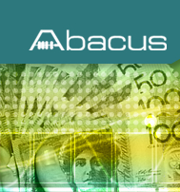

ABACUS NCS-50 BANKNOTE AND COIN SCALE
The Abacus NCS-50 banknote and coin counting scale accurately weighs banknotes, coins, vouchers and coupons, using some of the worlds most advanced digitalized electronics.
This fast and user friendly cash scale is specifically designed for cashing up tills; float preparation, instant cash checks and banking.

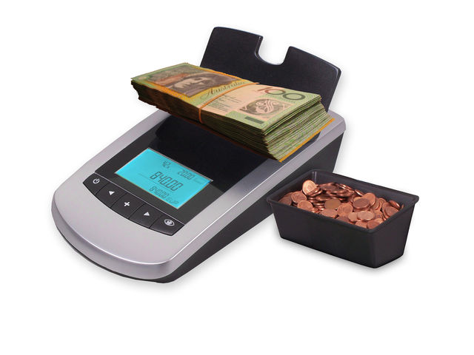
FEATURES
- Fully Portable
- Mains power or 9 volt battery
- Back lit easy-to-read display with running grand total
- Small foot print to save on desk and counter space
- Choice of 3 currencies
- Optional banded note, bagged coin upgrade (NCS-50+)

SPECIFICATIONS
Weighing Capacity 1kg
Dimensions (W) 140mm x (L) 230mm x (H) 100mm
Weight 1.2kg

